COAL Project

Rush Hour Game

1. Introduction
For my COAL semester project, I developed "Rush Hour," a grid-based simulation game using x86 Assembly Language. The main idea is simple: you are a taxi driver navigating a busy city. You have to pick up passengers and drop them off at their destinations to earn money (points) while avoiding traffic and obstacles.
I chose this project to practice low-level programming concepts like managing memory, handling keyboard inputs directly, and using file handling for saving game data.

2. Game Features
The game includes the following features:
- Main Menu: When the game starts, you can choose to Start New Game, Continue (Load Game), view the Leaderboard, or read instructions.
- Two Taxis: You can choose between a Yellow Taxi (Fast but high penalty for crashes) or a Red Taxi (Slower but takes less damage).
- Random Maps: Every time you start a new game, the board is generated differently. The code ensures about 35% of the map is buildings and the rest is road, and that you never get stuck in a closed-off area.
- Traffic System: There are NPC cars moving in straight lines (horizontal or vertical). You have to time your movements to avoid them.
- Save/Load: If you press 'P' or exit, you can save your current progress. The game writes the board state to a file so you can resume later.
- Leaderboard: The top 10 scores are stored in a text file (highscores.txt). If you get a high score, it updates the file.

3. Technical Implementation
I used a 20x20 2D array to represent the board. Each cell in the array holds a value representing a wall, road, car, or passenger.
- Movement: I used keyboard interrupts to detect arrow keys. When a key is pressed, the code checks the array to see if the target square is a wall or an obstacle.
- Graphics: Since we aren't using a game engine, I used console video memory to draw blocks of color for the cars and buildings.
- File Handling: For the leaderboard, the program opens the text file, reads the scores into an array, sorts them, and writes them back if there’s a new record.

4. Controls
- Arrow Keys: Move the taxi.
- Spacebar: Pick up or drop off a passenger.
- P: Pause the game.
- Esc: Exit to menu.

5. Interface & Screenshots
Fig 1: The Main Menu
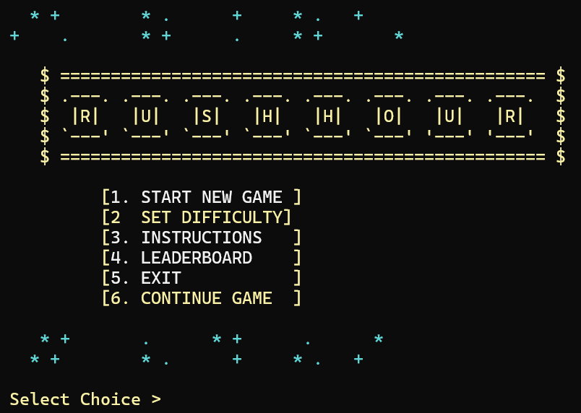
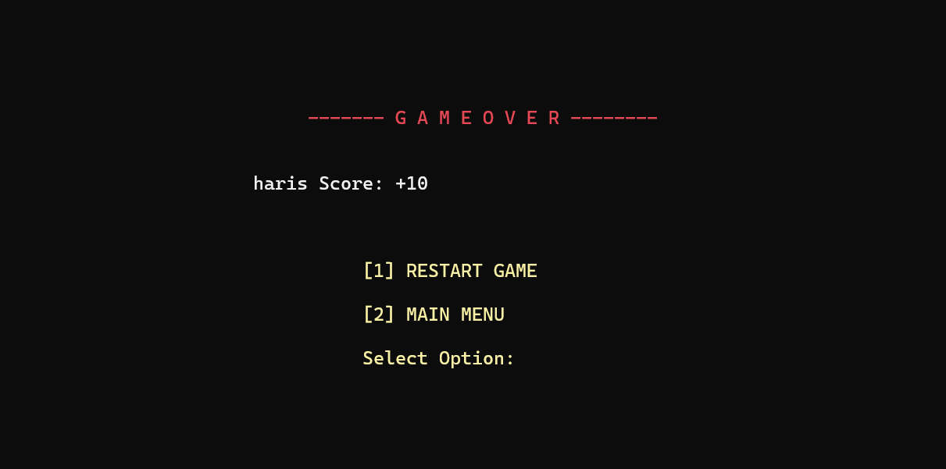
Fig 2: Gameplay showing the 20x20 Board
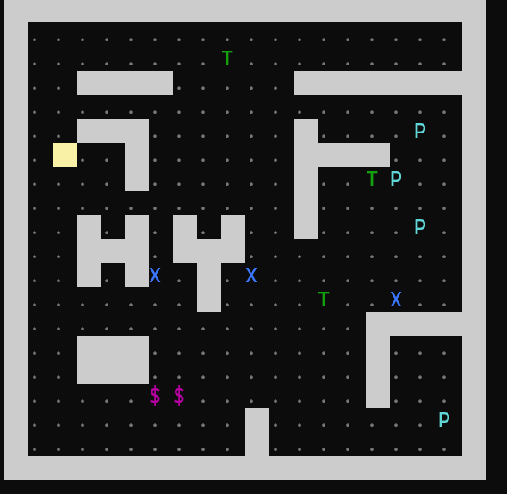
Fig 3: The Leaderboard Screen
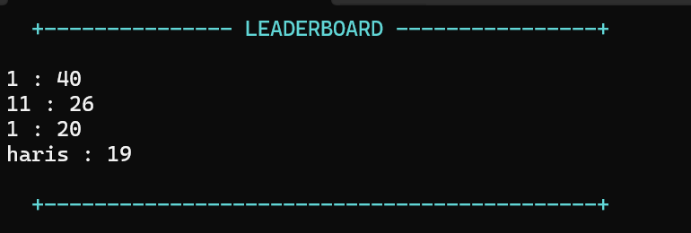

6. Challenges Faced
The hardest part of this project was the collision detection for the other cars. At first, the NPC cars would sometimes drive through walls or crash the game. I fixed this by adding better checks in the movement loop.
Another challenge was File I/O. Reading the numbers from the text file and converting them from ASCII characters to actual integers for sorting took some time to figure out.

7. Video Demo
Here is a video link showing the gameplay and features:
https://drive.google.com/file/d/1S7o_SWdVZUg_d4Y6lUUL0j93ADwJEEDx/view?usp=sharing

8. Conclusion
"Rush Hour" works smoothly and meets all the project requirements. It features a complete game loop with a win/loss condition, persistent data (saving), and dynamic difficulty. Working on this really helped me understand how the computer handles logic and memory at a low level.

